Actigraphy Report

**Subject ID:** 100126

**DOB:** 1/1/1990 **Age:** 27 **Gender:** Female

**Recording Period:** from 5/5/2017 12:00:00 PM to 5/12/2017 9:58:00 AM

**Summary Statistics:**

|  |  |  |  |  |  |  |  |  |
| --- | --- | --- | --- | --- | --- | --- | --- | --- |
|  | Bed Time | Get Up Time | Time in Bed (hours) | Total Sleep Time (hours) | Onset Latency (minutes) | Sleep Efficiency (percent) | WASO (minutes) | #Awak. |
| Min | 6:41:00 PM | 7:01:00 AM | 7:01:00 | 6:10:30 | 1.50 | 81.72 | 22.50 | 33 |
| Max | 12:19:00 AM | 9:03:30 AM | 13:02:30 | 11:30:00 | 76.00 | 93.50 | 89.00 | 57 |
| Avg | 10:43:21 PM | 8:09:04 AM | 9:25:42 | 8:20:25 | 17.57 | 88.50 | 37.86 | 41.57 |

**Daily Statistics:**

|  |  |  |  |  |  |  |  |  |
| --- | --- | --- | --- | --- | --- | --- | --- | --- |
| Date | Bed Time | Get Up Time | Time in Bed (hours) | Total Sleep Time (hours) | Onset Latency (minutes) | Sleep Efficiency (percent) | WASO (minutes) | #Awak. |
| Friday 5/5/2017 | 10:31:30 PM | 9:03:30 AM | 10:32:00 | 9:39:00 | 2.50 | 91.61 | 35.00 | 40 |
| Saturday 5/6/2017 | 11:39:00 PM | 8:52:30 AM | 9:13:30 | 8:37:30 | 3.00 | 93.50 | 32.00 | 50 |
| Sunday 5/7/2017 | 11:46:00 PM | 8:23:00 AM | 8:37:00 | 7:23:00 | 26.00 | 85.69 | 25.50 | 37 |
| Monday 5/8/2017 | 10:46:30 PM | 8:40:00 AM | 9:53:30 | 8:05:00 | 76.00 | 81.72 | 22.50 | 38 |
| Tuesday 5/9/2017 | 12:19:00 AM | 7:20:00 AM | 7:01:00 | 6:10:30 | 11.00 | 88.00 | 29.50 | 33 |
| Wednesday 5/10/2017 | 6:41:00 PM | 7:43:30 AM | 13:02:30 | 11:30:00 | 3.00 | 88.18 | 89.00 | 57 |
| Thursday 5/11/2017 | 11:20:30 PM | 7:01:00 AM | 7:40:30 | 6:58:00 | 1.50 | 90.77 | 31.50 | 36 |

Each day represented above is from 12:00:00 PM to 12:00:00 PM on the next day.

|  |
| --- |
| 1 **Subject ID:** 100126 |
| **DOB:** 1/1/1990 |

**Actogram:** 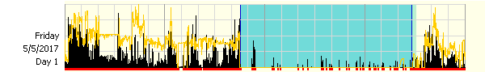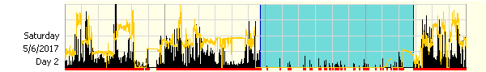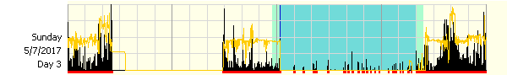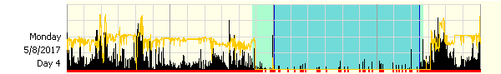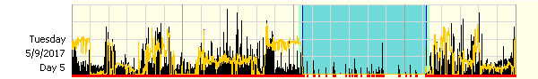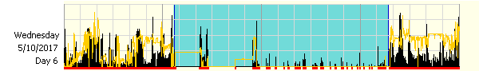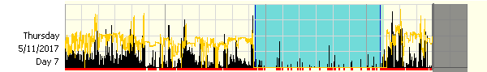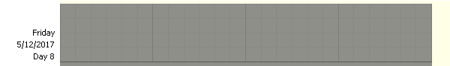



Activity Scale: 1048/0, White Light Scale: 84989.7/0.1